(“Resilience‑based interventions in the public sector workplace: a systematic review”)

Previous studies have advocated the benefits of resilience-based interventions for creating a healthy and sustainable workforce. However, resilience is defined and measured in diverse ways. Therefore, the aim of this
systematic review is (1) to identify how resilience is defined within different workplace interventions, translated
into intervention content, and measured in these interventions; and (2) to synthesize the effectiveness of these
interventions.

Defining ‘resilience’ is a challenge [8–11]. Often resilience can be defined as the ability to bounce back from stress or the process of positively adapting to adversities [12, 13]. However, a brief examination of the existing resilience literature shows a proliferation of definitions [11, 14]. Previous studies tried to provide clarity by distinguishing three definitional categories of resilience. Most definitions either conceptualize resilience as a trait, as an outcome, or as a process [15]. In the first category, resilience is seen as a personal trait that protects someone against the potential impact of adverse events. It is considered a personal, intrinsic characteristic [15, 16], but some researchers in the trait orientation define it as an ability. This would imply that resilience can be trained [16, 17]. Both views belong to the trait orientation since both see resilience as (1) an intrinsic quality; and as (2) independent of adversity exposure. However, this trait view has faced criticism for its limitations, such as the observation that even highly resilient individuals may struggle under significant stress and the observed influences of external factors [10, 18–20]. These critiques have led to the development of other perspectives on resilience. Such as a second category, in which resilience is seen as an adaptive outcome, defining it as the maintenance or restoration of mental health after exposure to significant adversity. The focus is on the present exposure to adversity and the corresponding coping process. This success of the coping process is measured in terms of mental health outcomes such as personal growth or wellbeing [15]. These mental health outcomes can be modified by so-called resilience factors, which can consist of internal resources (e.g. self-efficacy and coping abilities) and external assets (e.g. presence of social support) [9, 15, 21, 22]. In the last category, resilience is seen as a process, and is often defined as the dynamic process of adaptation itself, which is characterised by the utilization of internal resources and external assets. These protective factors, i.e. internal resources and external assets, facilitate the adaptation to the adversity, leading to better outcomes [11, 20]. The process orientation considers the phases before, during and after adversity exposure when investigating the protective factors and the adaptation to the adversity [16]. Post-adversity, resilient individuals either show stable mental health, or only a temporary disturbance, followed by a relatively quick recovery, or even growth [15]. Lastly, the process of resilience can vary in different contexts and domains [16, 23]. In summary, within the trait orientation resilience is an individual characteristic and independent of adversity exposure, while in both the process- and outcome orientation it depends on adversity exposure. The outcome orientation focuses on the result (e.g. stable or increased wellbeing), while the process orientation emphasizes the journey rather than solely the outcome [15, 16]. In both orientations, the influence of external assets on resilience opens possibilities for interventions aimed at improving resilience and mental health.

As workloads get heavier and burn-out rates are rising,
more employers seem interested in resilience-based
interventions to sustain a healthy and resilient workforce
[4, 25].

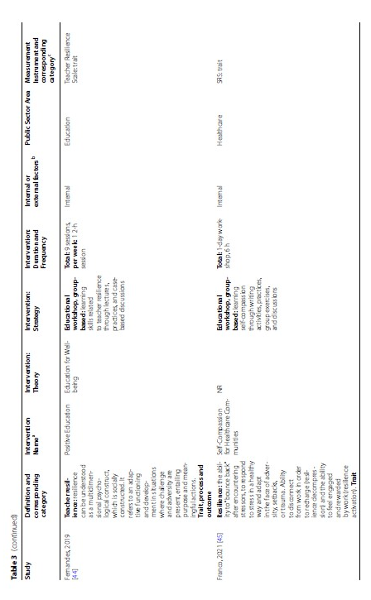
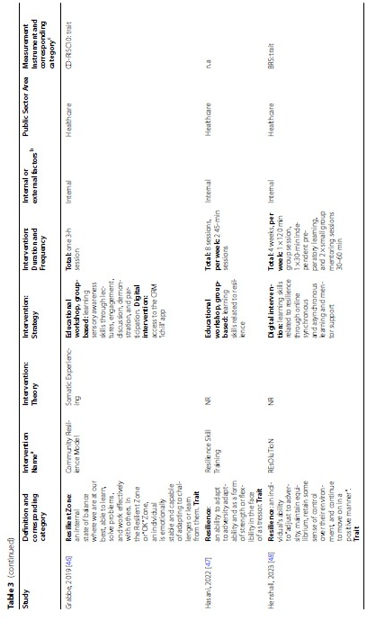

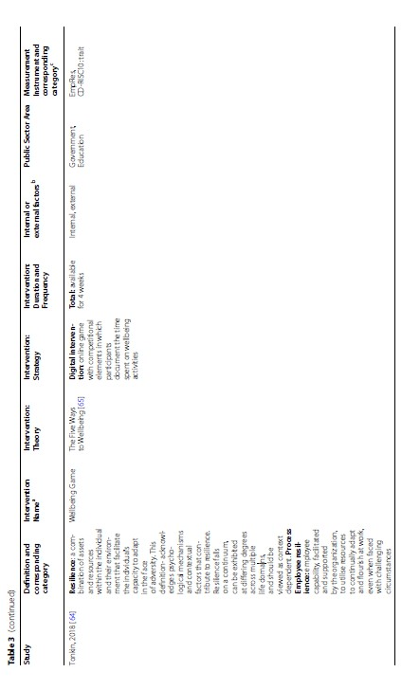

Most
of these studies either used the Connor-Davidson Resilience
Scale (CD-RISC) [69], the CD-RISC10 [70], or the
Resilience Scale (RS) [71, 72], or a shorter, adapted version
like the RS-13 or RS-14 [73–75]. Other studies used
a unique scale, such as the Brief Resilience Scale (BRS)
[13]. The theoretical background of these measures fit
within the trait-orientation and are thus consistent with
the chosen definitions.

Most of these educational workshops were concerned
with teaching their own selection of skills related
to resilience, such as emotion management, interpersonal
skills and self-reflection [40, 44, 47, 50, 78], a selection
of skills related to mindfulness [58–60, 77], or skills
related to stress and coping [51, 53, 54]. Some interventions
focus on a specific psychosocial skill, like self-compassion,
emotional intelligence or mental strength [45,
55, 66]. Other educational workshops were about selfcare
practices [63], sensory awareness [46], biofeedback
and meditation [49], or focused on scenario planning
[40]. For more details about the educational content, see
Table 3. Three of these group-based interventions offered
the additional opportunity to continue learning and
training with an online app or website. Whereas seven
interventions were fully smartphone- or app-based.
Three of these digital interventions contain psychoeducational
content aimed at emotions or self-compassion
by means of mindfulness [52, 67, 68]. Two are aimed at
well-being, one through game-based elements [64] and
one through goal setting aimed at awareness, sleep and
emotions [77].

